# Experiment-2.2

## Student Name: Nabha Varshney UID: 20BCS4995

**Branch: CSE Section/Group: 20BCS-DM-704 (A)**

## Semester: 6th Date of Performance:12th Apr 2023 Subject Name: Competitive Coding II Subject Code: 20CSP- 351

**Aim** – To demonstrate the concept of Graphs

## Objective-

* The objective is to build problem solving capability and to learn the basic concepts of data structures.
* The implementation of find the difference which shows and brushes up the concept of Graphs and can be solved through various approaches.
* The implementation of predict the winner problem in C++.

## Find the difference

<https://leetcode.com/problems/find-the-difference/>

**Code –**

class Solution {

public:

    char findTheDifference(string s, string t) {

        sort(s.begin(), s.end());

        sort(t.begin(), t.end());

        for(int i=0; i<s.size(); i++) {

            if(s[i] != t[i]) return t[i];

        }

        return t.back();

    }

};

## Output -

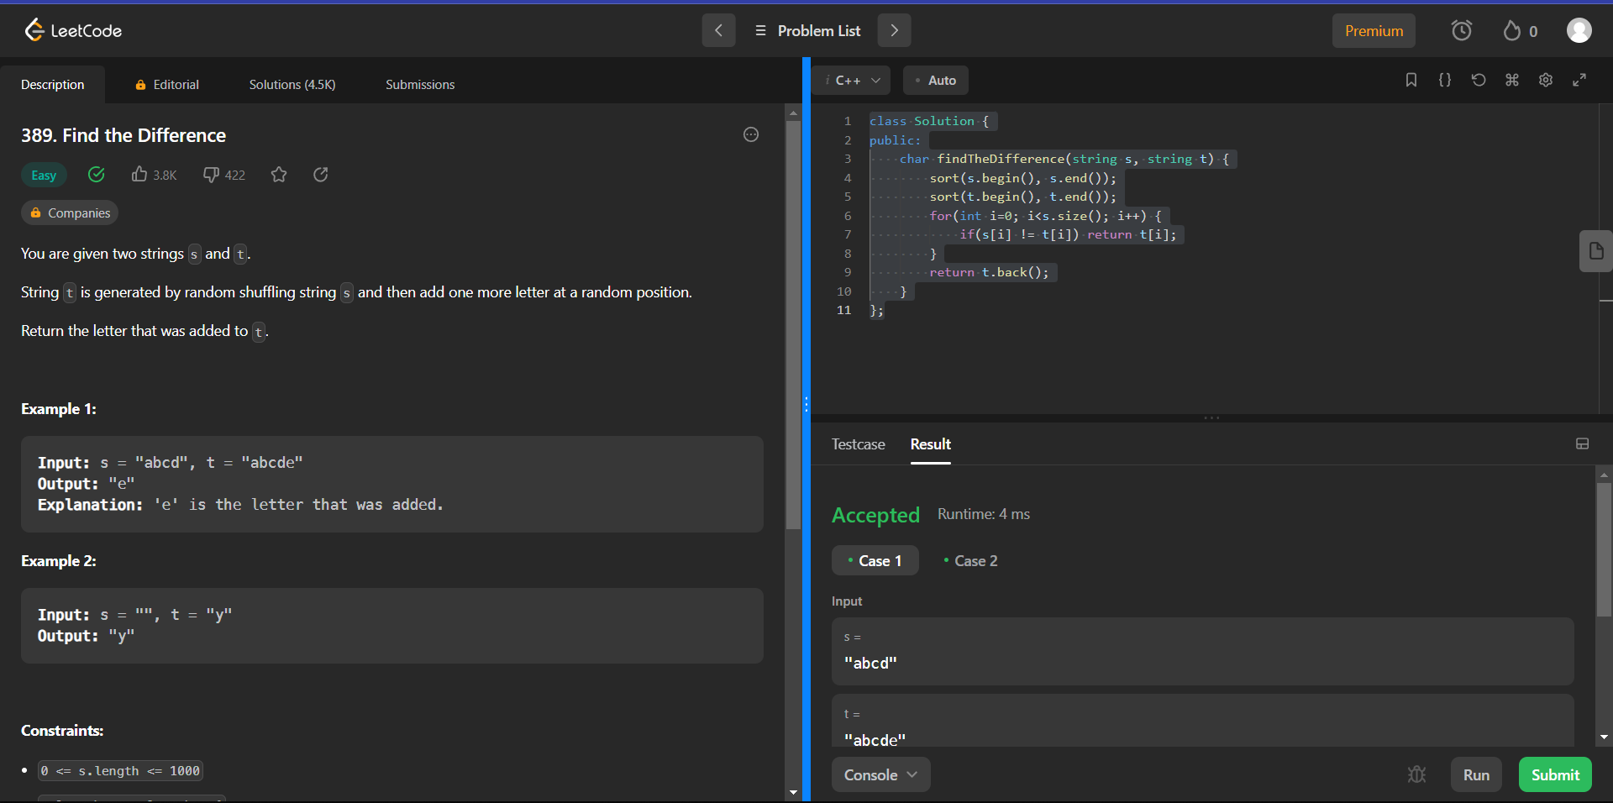

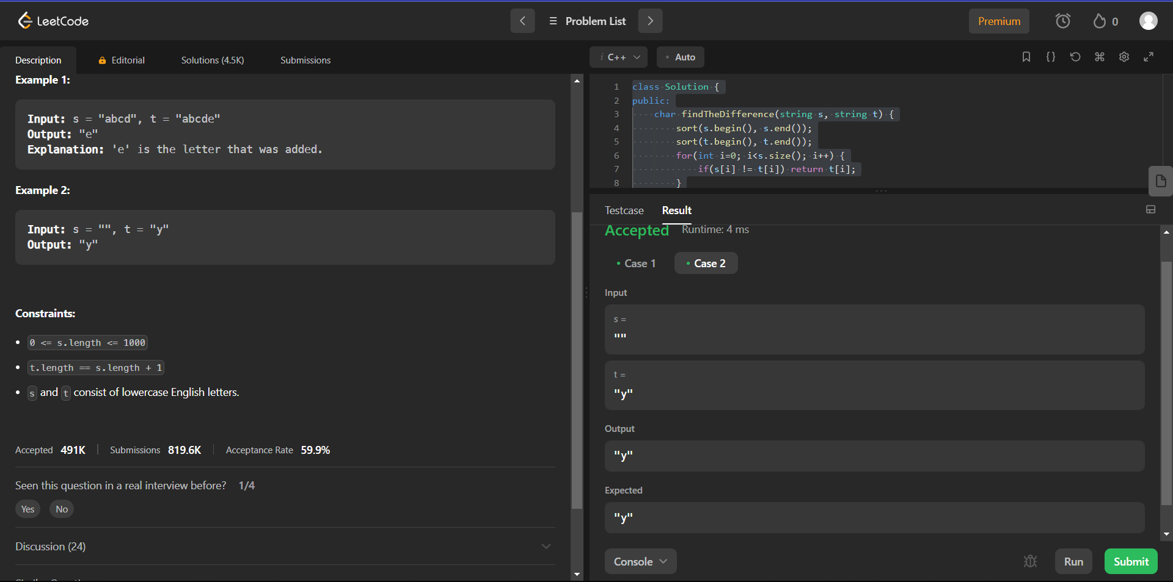

1. **Predict the winner**

<https://leetcode.com/problems/predict-the-winner/>

**Code -**

class Solution {

public:

    int solve(vector<int>&nums,int i, int j){

        if(i>j){

            return 0;

        }

        if(i==j){

            return nums[i];

        }

        int option1 = nums[i] + min(solve(nums,i+2,j),solve(nums,i+1,j-1));

        int option2 = nums[j] + min(solve(nums,i+1,j-1),solve(nums,i,j-2));

        return max(option1 , option2);

    }

    bool PredictTheWinner(vector<int>& nums) {

        int p1Score = solve(nums,0,nums.size()-1);

        int total_Score = 0;

        for(int i=0;i<nums.size();i++){

            total_Score += nums[i];

        }

        int p2Score = total_Score - p1Score;

        if(p1Score>=p2Score){

            return true;

        }

        else{

            return false;

        }

    }

};

## Output –

